



Title of the Thesis in English

—

Title of the Thesis in German

Seminar / Bachelor / Master Thesis

of

Your Name

Date of Submission

Matriculation number

At the Department of Economics and Management

Institute for Information Systems (WIN)

Information Systems III

Reviewer: Prof. Dr. Jella Pfeiffer

Supervisor: Name of Your Supervisor

Contents

1 Introduction 4

2 Brief overview of the content of chapters 4

2.1 Introduction 4

2.2 Chapter on related work/theories/literature 4

2.3 Discussion 5

2.4 Conclusion 5

3 Figures and Tables 6

3.1 Experimental Design 6

3.2 Procedure 8

3.3 Results 9

4 Citation 11

4.1 Citing literature 11

4.2 Citation style 11

4.3 Indirect citation (in-text citation) 12

4.4 Direct quotes 12

5 Bibliography 14

5.1 Basics 14

5.2 DOI or URL 14

5.3 Different type of Sources 14

6 Combinatorial Auctions 17

6.1 Mechanism Design 17

6.1.1 Definition 17

6.1.2 Revelation Principle and Gibbard-Satterthwaite Theorem 19

6.1.3 Vickrey-Clarke-Grooves Mechanism 20

7 Conclusions 21

7.1 Summary 21

7.2 Limitations and Future Research 21

7.3 Contribution 21

References 22

Appendix xxiii

# Introduction

Scientific papers have standardized structures. There are different standards for different types of papers. You should make sure that the paragraphs are not -too short (i.e. at least 3-4 sentences). This is still a rather short paragraph.

This would then be a new paragraph. But this paragraph would be too short.

# Brief overview of the content of chapters

Below we give you a few tips for writing the different chapters.

## Introduction

1. Problem definition and motivation
2. State of research, building on this, identify research gap and research question(s)
3. Aim of the work and own methodological approach to answering the research question(s): Paragraph usually begins with: The goal of this thesis/work/manuscript is ....
4. Expected scientific (and practical) contribution [=Contribution]
5. Sometimes follows: Outline [formulated]

## Chapter on related work/theories/literature

1. What theories and principles are there?
2. Focus on a few, central ones
3. Absolute basics do not need to be explained. You can assume that the readers already know a lot. (specialist audience!)
4. Often subdivided into subheadings according to the different types of foundations/theories
5. Not yet refer to own work and own approach, so never "pre-reference"

🡪 The aim is to make the research gap clear. You are also welcome to explicitly name and elaborate on this. [This is the only place where implicit reference is made to your own work.]

The other chapters between the basic chapters and the conclusion are individually very different. Your own contribution should be in the foreground in these further chapters.

## Discussion

1. The discussion reflects the results of the work
   1. In empirical works, the results section reports the data situation (e.g. hypothesis tests) in a very dry manner and these results are only interpreted in the discussion.
   2. In purely normative papers, the discussion often coincides with the presentation of the results, as the two parts are more difficult to separate. For this reason, normative papers often do not have a separate discussion chapter. Discussion then takes place in the previous chapters.

## Conclusion

Depending on the length of the thesis, this chapter does not need to be subdivided.

1. Summary
   1. Varies depending on the level of detail of the previous discussion. In empirical papers: Brief summary of findings and higher-level analysis of results
   2. Reference to research questions and the extent to which they have been answered
2. Limitations/critical appraisal and outlook
   1. What problems were encountered in the present work?
   2. How can these be addressed in future work?
   3. What other future, related research topics should be addressed in the future?
3. Contribution:
   1. What conclusions can be drawn?
   2. What contributions does the work make to research and practice? [Contribution]

# Figures and Tables

Here you will find examples of how to insert figures and tables.

## Experimental Design

In the NO-FILTER condition, ten randomly chosen projects were shown to the participant on the overview page (see Figure 1). There was a short description of each project on the list, as well as a photo, the name, the amount of money already lent to the project and one sentence describing the project. The participants could then click on each project in any order to access the detailed project description page, which described the project in a longer text of mostly two to three paragraphs (see Figure 2). In addition, information was provided on the repayment schedule. The participants could navigate between the overview page and the detailed description in any order and as long they wanted. Finally, they had to choose one project by clicking on the “Choose” button in the detailed project description.

Condition STANDARD: Filter Followed by Joint Evaluation

In the STANDARD condition, participants could set filters for several criteria (see Figure 3). They were not forced to set filters, but all participants used them. Subsequently, they were asked to rank the order of the filter criteria they selected according to their importance (see Figure 4). Afterwards, they saw the same overview page and the detailed project description page as the participants in the NO-FILTER condition (see Figure 1 (right) and Figure 2). However, the ten projects they saw were not randomly chosen, but selected on the basis of their filters and importance sorting.

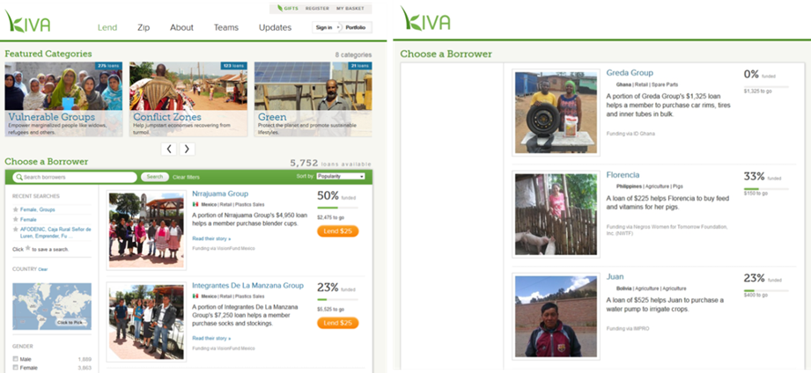

Figure 1: Overview page. Left: Original Screenshot from KIVA (www.KIVA.org/lend). Right: Screen that participants saw in the experiment (overview page).

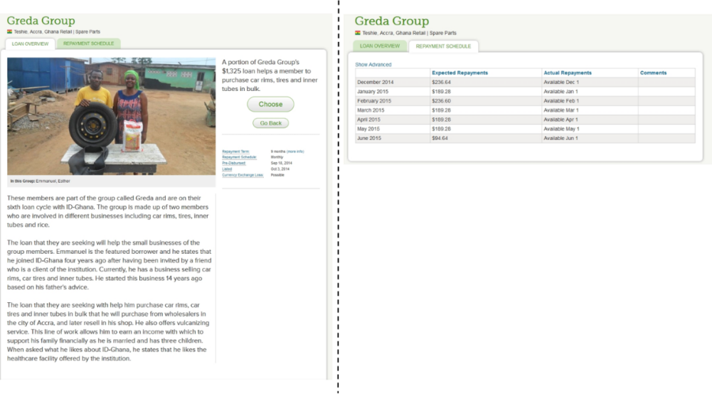

Figure 2: Detailed Project Description Page with repayment schedule.

As filter criteria, the participants could set: country, gender, sector, groups or individuals, and attributes (for example, green, start-up, youth, fair trade, etc.). These are the same filters the KIVA offered on the standard screen at the time of our experiment. If less than ten projects met the filter criteria, the least importance criteria were relaxed. For example, if a participant had set the two filters gender=females and sector=education and had indicated sector as more important than gender, but only eight projects fulfilled both criteria, we selected these eight projects and then selected another two projects randomly drawn from all projects in the education sector with entrepreneurs of any gender. Participants were fully informed about this procedure (see text in Figure 4).

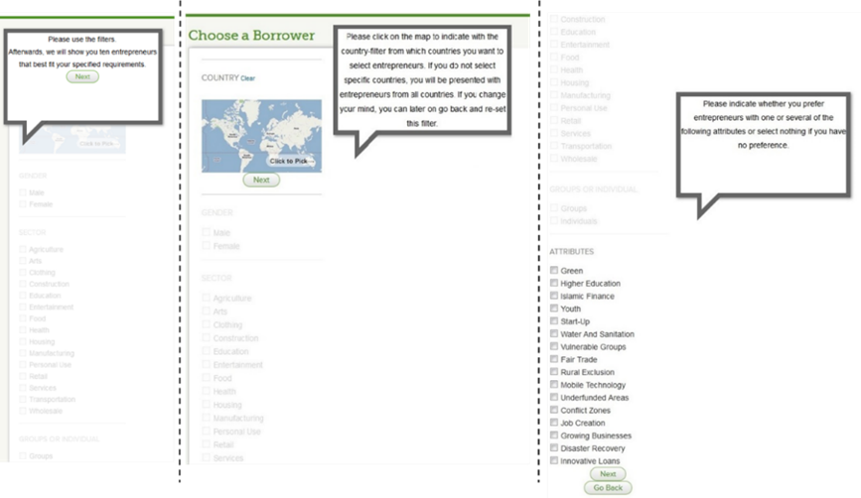

Figure 3: First step of the attribute-based selection process: Filter.

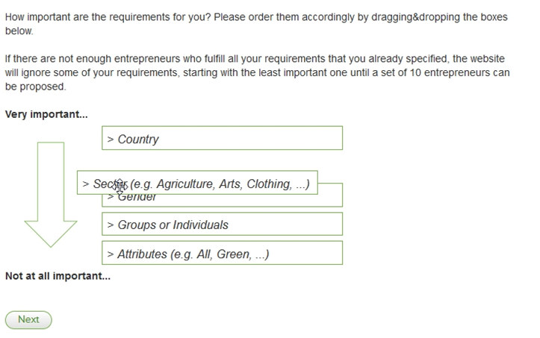

Figure 4: Step two of the attribute-based selection process: Importance Sorting.

## Procedure

Figure 5 illustrates the experimental procedure. In addition to a lab session that lasted about 45 minutes, the participants completed two short online surveys: a pre-questionnaire two weeks before this session and a post questionnaire 12 weeks later. In the pre-questionnaire, we asked participants what their goals would be when lending money, the situation-specific thinking style they would use when deciding this, and other control variables, like their age and gender. The two-week delay allowed us to measure the constructs without making them overly salient during the lab study, thereby reducing the risk that the elicitation of these constructs would potentially influence participants during the lab session. In the post questionnaire, we asked the participants how satisfied they still were with their choice in the lab, and how often they had revisited the platform since that time. We considered the 12-week delay between the lab session and the post questionnaire sufficiently long to gauge the impact of our manipulations and of any long-lasting effects resulting from the experience in the experiment. There was no attrition between the pre-questionnaire and main experiment (the pre-questionnaire was a pre-requisite in register for the experimental session), but only 69 (78.4%) of the 88 participants completed the post questionnaire.

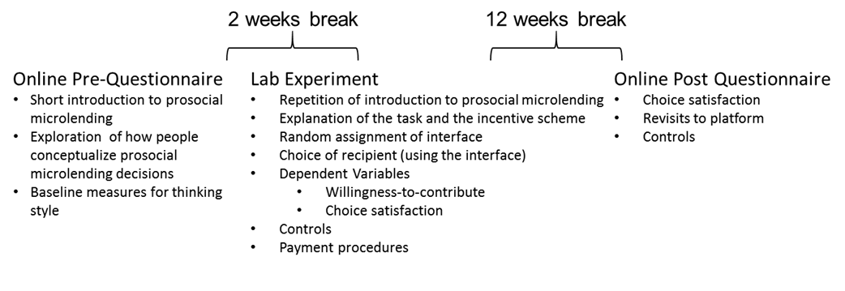

Figure 5: Experimental Procedure.

## Results

***Testing our Hypotheses***

Table 1 shows the descriptive statistics of the dependent variables and mediators that we use for testing our hypotheses. In particular, we conceptualize analyticalStyle (experientialStyle) as the change in analytical (experiential) thinking style evoked by the interface in the main experiment. In particular, we calculate the difference between the scores of the analytical (experiential) thinking style scales of the pre-questionnaire and the main questionnaire. We see that, after a choice has been made, the thinking style becomes less analytical (two-sided t-test, t(87)=4.46, p<0.01) and slightly more experiential (t(87)=-1.74, p=0.09). (A positive value indicates an increase in the analytical/experiential thinking style after the participants had made their choice in the lab experiment, compared to the one they had anticipated in the pre-questionnaire.) Furthermore, Table 1 reveals that the perceived strategy restrictiveness is, with an average of 3.60, rather in the middle of the scale. In contrast, immediately after the participants had made their choice, their choice satisfaction is relatively high at 5.45, and also remains on a high level when asked again 12 weeks later in the post questionnaire (both scales range from 1 to 7). Finally, the participants were rather generous: On average, they contributed $60.81 to the chosen project and only took $39.19 in cash.

|  |  |  |  |  |  |
| --- | --- | --- | --- | --- | --- |
| **variable** | **mean** | **SD** | **variable** | **mean** | **SD** |
| Dependent variables and mediators (thinking style: min: 1, max:5, all others min:1, max:7) | | | | | |
| analyticalStyle | -0.37 | 0.79 | experientialStyle | 0.12 | 0.65 |
| perceived strategy restrictiveness | 3.60 | 1.26 | choice satisfaction main questionnaire | 5.45 | 1.08 |
| choice satisfaction post questionnaire | 5 | 1.27 | willingness-to-contribute | 60.81 | 25.11 |

Table 1: Descriptive statistics of mediators and dependent variables

To test our Hypotheses 1, 2, and 3 about the effects of the interfaces on the different dimensions of the platform’s success, we conducted a separate OLS regression for choice satisfaction and willingness-to-contribute. We computed two models for choice satisfaction, one that regresses on the choice satisfaction that was reported immediately after the choice in the lab (choice satisfaction main) and one that regresses on the choice satisfaction reported in the post questionnaire (choice satisfaction post). The STANDARD condition was coded as the reference, so that the coefficients for NO-FILTER and SINGLE reflect the respective differences when comparing these conditions with STANDARD. In particular, the difference between the condition that supports an attribute-based selection and the one that does not, is reflected in the coefficient for NO-FILTER. The difference between the condition that supports joint evaluation and the one that supports only single evaluation is reflected in the coefficient for SINGLE. Table 2 summarizes the results of the three models. …

|  |  |  |  |  |  |  |
| --- | --- | --- | --- | --- | --- | --- |
|  | **Choice satisfaction main** | | **Choice satisfaction post** | | **Willingness-to-**  **Contribute** | |
| **Reference category: STANDARD** | coeff. | p-value | coeff. | p-value | coeff. | p-value |
| NO-FILTER | .039 | 0.887 | .131 | 0.727 | -3.42 | 0.603 |
| SINGLE | -.618 | 0.029 | -.429 | 0.266 | 12 | 0.073 |
| constant | 5.60 | <0.010 | 5.10 | <0.010 | 57.92 | <0.010 |
| *N* | 88 | | 69 | | 85 | |

Table 2: Results of Hypothesis 1, Hypothesis 2, and Hypothesis 3.

***Additional Analyses***

AND SO ON

# Citation

## Citing literature

**We recommend using reference management programs like Zotero, Citavi or Mendely:**

* Manage PDF documents
* Automatic import of source information via plug-ins in the browser, PDF, databases, etc.
* Annotations, notes, tagging, ...
* Comparison of the different software options: <https://mediatum.ub.tum.de/doc/1316333/1316333.pdf>
* These programs cannot do magic, check if the stored informations are correct! This is your responsibility!
  + Garbige in 🡪 Garbige out

## Citation style

* American Psychological Association (APA) >= 6 Citation style
* Please view very good instructions online: <https://www.scribbr.de/category/apa-standard/>
* Both direct quotations (🡪 adopted passages in the wording) and indirect quotations (🡪adoption of an idea) must be identified
* Each source used in the paper (book, article in a collective work, journal article, website (with retrievel date)) must be referenced!
* In most cases, there is a publication behind a website, e.g.: behind <https://sloanreview.mit.edu/projects/artificial-intelligence-in-business-gets-real/> hides the following source: Ransbotham, S., Gerbert, P. Reeves, M., Kiron, D., & Spira, M. (2018). Artificial intelligence in business gets real*. MIT Sloan Management Review and The Boston Consulting Group*.

## Indirect citation (in-text citation)

**Parenthetical**: There is a correlation between social media usage and anxiety symptoms in teenagers (Parker, 2019).

**Narrative**: Parker (2019) found a correlation between social media usage and anxiety symptoms in teenagers.

**One Author**

1. An early study of this phenomenon (Barr, 1999)...This phenomenon has been observed before (Beutel, et al., 2004)...This phenomenon has been studied before (Satariano, 2019)...
2. Barr (1999) already dealt with this phenomenon ...
3. Already in 1999 Barr dealt with this special phenomenon...

**Two authors:**

* (Cadogan & Lee, 2013)
* But: Already Cadogan and Lee (2013) dealt with this special phenomenon...

**Three or more authors:**

* generally only ever cite the first author and then with et al.
* Exmple: wrong (Baschek, Bredenkamp, Öhrle & Wippich, 2001); correct (Baschek et al., 2001)

**Using multiple sources:**

* The various sources are separated by a semicolon and sorted alphabetically
* Example: Several studies have replicated these results (Brown, 2009; Porter, 2004; Smith, 2015, 2017).

If you cannot find the original source (which you should always try), you should cite it through the secondary source that led you to it, using the phrase “as cited in”.

(Parker, 1978, as cited in Bloom et al., 2017)

## Direct quotes

1. Literal quotations must be reproduced verbatim and placed between quotation marks!
2. Example: APA direct quote According to a recent paper, “quotes can be useful in academic writing” (Singh et al., 2019, p. 25).
3. If the quote is 40 words or more, format it as a block quote.

The opioid addiction crisis in the United States has grown to result in approximately 140,000 deaths per year, and there is increasing pressure on government to confront this issue. A recent New York Times editorial argued that

lawmakers and regulators need to stop pharmaceutical companies from marketing drugs like OxyContin and establish stronger guidelines about how and when doctors can prescribe them. These drugs are often the last resort for people with cancer and other terminal conditions who experience excruciating pain. But they pose a great risk when used to treat the kinds of pain for which there are numerous non-addictive therapies available. (The Editorial Board, 2018)

1. If you only want to quote an excerpt directly, you can use [...] to indicate that you have left something out. It is important that this does not change the content of the quoted text.

„[…] it is possible that participants attended less to effectiveness ratings for charities because they wished to have agency when making charitable decisions […]” (Berman et al. 2018 p. 827).

# Bibliography

## Basics

* List all Materials used
* Sort alphabetically by author’s name (within an author chronologically - with oldest source first)
* Use indents
* DO NOT SORT BY SOURCE TYPE
* Do not use bullet points

## DOI or URL

Works that can be accessed online usually have a URL or DOI (digital object identifier). A DOI is often used for scientific publications and books, while a URL is more common for other online publications.

Use the following guidelines:

* If available, always add a DOI
* A DOI is preferred over a URL (because it never changes)
* Include the protocol (http:// or https://) for both DOIs and URLs
* Do not add a period after the DOI or URL

## Different type of Sources

**Journal Article:**

Author, A., Author, B. & Author, C. (Date). Title of Article. *Title of Journal*, Issue, pagenumber.

Example:

Peukert, C., Pfeiffer, J., Meißner, M., Pfeiffer, T. & Weinhardt, C. (2019). Shopping in Virtual Reality Stores: The Influence of Immersion on System Adoption. *Journal of Management Information Systems*, *36*(3), 755-788.

**Dissertation:**

Author last name, Initials. (Year). Dissertation title (Publication No. Number) [Type of dissertation/thesis, University Name]. Database Name.

Example:

Ford, L. (2015).*The use of experiential acceptance in psychotherapy with emerging adults* (Publication No. 3731118) [Doctoral dissertation, Pepperdine University]. ProQuest Dissertations and Theses Global.

**Book chapter:**

Author, A. (Year). Title of Chapter. In *Titel of Book* (pagenumber).

Example: Beutel, J., Kasten, O., Mattern, F., Römer, K., Siegemund, F., & Thiele, L. (2004). Prototyping Wireless Sensor Network Applications with BTnodes. In *Lecture notes in computer science* (pp. 323–338). <https://doi.org/10.1007/978-3-540-24606-0_22>

**Book:**

Primary contributors (Publication date). *Title* (Edition). Publisher. DOI

Smith, T., & Williams, B. M. (2020). *The citation manual for students: A quick guide* (2nd ed.). Wiley. <https://doi.org/10.1000/182>

**Webseite:**

Primary contributors (Publication date). *Title*. Container title. URL

Example:

Slat, B. (2019, April 10). *Whales likely impacted by Great Pacific garbage patch*. The Ocean Cleanup. https://www.theoceancleanup.com/updates/whales-likely-impacted-by-great-pacific-garbage-patch/

For APA (7th edition), a retrieval date only needs to be specified if the content of the website may change over time, e.g. for Wikipedia articles or social media posts

If they are not articles, but rather pure websites (often the case in Intro, then enter the URL as a footnote, e.g. [www.ikea.de](http://www.ikea.de))

See also: https://www.scribbr.com/apa-examples/website/

**Conference Paper:**

Author name, Initials. (Year, Month Day–Day). *Paper title* [Paper presentation]. Conference Name, City, State, Country. URL

**In online-Proceedings or Journal:**

Author name, Initials. (Year). Paper title. *Journal Name*, *Volume*(Issue), page range. DOI or URL

Example:

Tattersall, I. (2009). Human origins: Out of Africa. *Proceedings of the National Academy of Sciences*, *106*(38), 16018–16021. <https://doi.org/10.1073/pnas.0903207106>

**If published in book form:**

Author name, initials. (Year). Paper title. In Editor initials. Last name (Ed.), *Book title* (pp. Page range). Publisher. DOI or URL

Example:

Shareef, M., Ojo, A., & Janowski, T. (2010). Exploring digital divide in the Maldives. In J. Berleur, M. D. Hercheui, & L. M. Hilty (Eds.), *What kind of information society? Governance, virtuality, surveillance, sustainability, resilience*(pp. 51–63). Springer. <https://doi.org/10.1007/978-3-642-15479-9_5>

# Combinatorial Auctions

*This is an excerpt from a sample chapter.*

Combinatorial auctions (CAs) are a part of electronic market design. Research in elec- tronic market design joins two disciplines: economics and computer science. Economical research focuses on game theoretical aspects by analyzing strategic behavior of self- interested agents. From the viewpoint of computer science, computational problems are addressed, such as ﬁnding the optimal allocation in auctions. As this work concentrates on computational aspects, we assume that the reader has a stronger background in computer science than in economics. Thus, in this chapter we will point out the main ideas of the economical perspective to provide some basic knowledge in this area.

## Mechanism Design

### Definition

Mechanism design was introduced by aims at implementing system-wide solutions to prob- lems in non-cooperative environments with multiple self-interested agents. Such problems can be political elections, public projects in which the participants themselves have to invest money, or allocation problems. Given that agents hold only private information about their preferences, a structure has to be chosen in which in equilibrium each agent behaves according to the designer’s or principal’s intentions. The designer can either act on behalf of the society, for example when collecting taxes for a public project, or she can pursue self-interests when, for instance, being an auctioneer. Since the agents’ information is private, the principal faces the problem that the agents might lie about their real valuations in order to inﬂuence the outcome according to their preferences. In most cases, whenever such manipulations occur, they damage the resulting system-wide welfare the participants to reveal their preferences is unfavorable. Therefore, the principal has to deﬁne other rules which lead to the desired outcome. The most common solution to this problem is to introduce monetary transfers providing incentives for the agents to behave truthfully. In mechanism design two economic areas are joined: game theory and social choice theory. In game theory the agents’ strategies are analyzed, and in social choice theory an outcome is selected according to a set of agents’ preferences. The outcome in social choice theory is determined by a social choice function, which is to be implemented by a mechanism. Formally we have a set of possible outcomes O and agents i ∈ I, |I| = n. Each agent i has a type θ $i ∈ Θi$ reﬂecting the possible preference sequences the agent can have. The type captures all of the agent’s private information relevant to her decision. The agent’s utility $u_{i}(o,θ_{i})$ over each outcome depends on her type; while $u_{i}(o_{1},θi) > u_{i}(o_{2},θ_{i})$ means that the outcome o1 is preferred over the outcome o2. The social choice function maps from the space of all types Θ to the space of all outcomes O,

$f : Θ_{1} ×Θ_{2} ×...×Θ_{n} → O.$ (2.1)

Examples for such social choice functions are allocation problems or political voting pro- tocols in which a candidate or a party is chosen. The most common objective of a social choice function is the maximization of the social welfare, the so called allocative-eﬃciency all utilities over all agents:

$f\left(θ\right)= \underset{o∈O }{\arg{max}}{\sum_{i∈I}{u_{i}\left(o,θi\right).}}$ (2.2)

Another objective is individual rationality; the agent’s payoﬀ is never less when participat- ing in the mechanism than her payoﬀ without participating. Additionally there is Pareto optimality. An outcome is Pareto optimal whenever none of the agents could perform better without causing another agent to perform worse than in the current situation. So far, we have learned what a social choice function is, and what typical objectives for the choices of outcomes are. Now, a mechanism has to be found which implements a given social choice function with one or several of these objectives. For this purpose, the agents’ possible strategies have to be speciﬁed together with an outcome function based on these strategies. The mechanism should guarantee an implementation despite the self-interest of the agents mechanism M is deﬁned on the strategy spaces Si of the agents:

$M = ((S_{1},...S_{n}),g(•))g : S_{1} ×...×S_{n} → O,$ (2.4)

where g is an outcome function and Si denotes all strategies or actions an agent i is allowed to take. A mechanism implements a social choice function if there is an equilibrium strategy proﬁle $s*(•) = (s* 1(•),...,s* n(•))$ of the game induced by M so that

$g(s_{1}^{*}(θ_{1}),...,s_{n}^{*}(θ_{n})) = f(θ_{1},...,θ_{n}), ∀(θ_{1},...,θ_{n}) ∈ (Θ_{1},...,Θ_{n}),$ (2.5)

where $s* i(θi)$ is the strategy agent i with type θi plays in the equilibrium. Please note that the equilibrium concept is not speciﬁed in this deﬁnition. It could, for example, be a Nash equilibrium. In this case, given the other players $j,j≠i$, conform to the equilibrium strategies $s^{*}j(θ_{j})$, no other player i has an incentive to unilaterally deviate from her equilibrium strategy. Other examples are the dominant strategy or the Bayes-Nash strategy equilibrium. The dominant strategy equilibrium facilitates it for the agents since the optimal strategy for an agent is independent of any strategies the other agents could play. Thus, the agents do not need to speculate about the way the others might behave. Informally, we could say that the concept of dominant strategies ”removes game theory from the problem” equilibrium is similar to Nash equilibriums, but assumes that agents have incomplete information about the opponents’ types. Therefore, agents use probability functions to speculate about the other agents’ preferences.

### Revelation Principle and Gibbard-Satterthwaite Theorem

In equation 2.3, we see that a mechanism deﬁnes the available strategies and the function for selecting an outcome. It is necessary that these strategies are kept simple so that they can be applied by the agents. The easiest strategies occur when choosing a direct mechanism asking the agents to report their types directly to the principal, $S_{i} = Θ_{i}$. Direct mechanisms lead to a centralization of the problem as agents report their types to a center that determines the outcome and reports it back to the agents. On the contrary, when applying indirect mechanisms agents have to think about how to transform their type into a strategy and the latter is reported to the mechanism. In other words, ”the computations that go on within the mind of any bidder in the non-direct mechanism are shifted to become part of the mechanism in the direct mechanism”. When applying these direct mechanisms agents may still lie about their true types. Mechanisms which, in contrast, succeed in establishing an equilibrium in which all agents tell the truth, are called incentive-compatible. In this case, it is in the interest of all agents to report their true types, $s_{i}^{*}(θ_{i}) = θ_{i}, ∀θ_{i}$ ∈ Θi . Further, if telling the truth is a dominant strategy, the mechanism is called strategy-proof. As will be shown later on, this can be achieved by the Vickrey-Clarke-Grooves (VCG) mechanism. We learned that the equilibrium strategy proﬁle $s^{*}(·)$ does not determine the concept of equilibrium. Some equilibrium concept must be chosen and implemented together with the mechanism. In the worst case, in order to ﬁnd out if a certain social choice function can be implemented by a certain mechanism with, for instance, dominant strategies, one would have to consider all possible mechanisms. However, research on mechanism design led to the revelation principle as a solution to this. It states that for any mechanism, there is a direct, incentive-compatible mechanism with the same outcome explanation for this principle consists in: the transformation from types into strategies, which occurs in the agents’ minds in indirect mechanisms, and which is used as a ﬁlter in the direct mechanism. That is, the direct mechanism ﬁrst ﬁlters all reports of the agents and simulates the indirect mechanism with the ﬁltered input. This principle is valid for the optimal mechanism as well. Thus, the search for a mechanism can focus on direct mechanisms. Therefore, if no direct mechanism can implement a given social choice function, then no indirect mechanism will do so. In contrast to the positive result of the revelation principle, there also exists a negative result, the Gibbard-Satterthwaite theorem. According to it, it is impossible to ﬁnd a mechanism with certain positive characteristics.

To understand the theorem, ﬁrst note that a social choice function is truthfully implementable if and only if the dominant strategy is to reveal the truth. Furthermore, a social choice function f is onto if for each o ∈ O at least one element in Θ exists so that f maps to o. Finally, a social choice function f is dictatorial whenever there is a dictator j among the agents so that for all outcomes, oj is strictly preferred to another outcome ok whenever the dictator j strictly prefers oj to ok. Obviously, this is an unwanted characteristic. It turns the Gibbard-Satterthwaite theorem impractical for real-life mechanisms since they allow manipulation. Gibbard-Satterthwaite Theorem: Given O is ﬁnite, |O|≥ 3, and the social choice function f is onto, then f is truthfully implementable in dominant strategies if and only if f is dictatorial. According to the theorem it is impossible to elicit the truth if dominant strategies exist. However, despite this result, the theorem can be circumvented by placing restrictions on the agents’ preferences, the way it is done in the VCG mechanism.

### Vickrey-Clarke-Grooves Mechanism

The VCG mechanism combines the following important virtues by introducing a special payment scheme. First, it implements social choice functions in dominant strategies. Thus, agents do not have to speculate which strategies the other agents might play, and they do not need to waste resources on learning about their competitors’ strategies. Second, the mechanism does not have to make any assumptions about the information agents have on each other. And, third, the VCG mechanism is allocative-eﬃcient (see equation 2.2), strategy-proof and non-dictatorial. AND SO ON...

# Conclusions

A brief conclusion does not require any further subdivision. In this case, the chapter title should read as follows: "Summary and conclusion".

## Summary

The summary of the work is optional. If you want to summarize the work again, please keep it rather short and do not repeat yourself too much.

## Limitations and Future Research

It makes sense to link each limitation to an idea of how it could be addressed in future work.

## Contribution

What are the contributions of your work to both science (and theory) and practice? Here you should try to think outside the box and take a rather broad view.

# References

Barr, M. (1999). *Programming Embedded Systems in C and C++.* Sebastopol: O´Reilly and Associates.

Beutel, J., Kasten, O., Mattern, F., Römer, K., Siegmund, F., & Thiele, L. (2004). Prototyping Wireless Sensor Network Applications with BTnodes. In H. W. Karl, *Proceedings of the 1st European Workshop on Wireless Sensor Networks* (S. 261-271). Berlin: Springer.

Cadogan, J. W., & Lee, N. (2013). Improper use of endogenous formative variables. *Journal of Business Research 66(3)*, S. 233–241.

Peukert, C., Pfeiffer, J., Meißner, M., Pfeiffer, T., & Weinhardt, C. (2019). Shopping in Virtual Reality Stores: The Inlfuence of Immersion on System Adoption. *Journal of Management Information Systems 36(3)*, S. 755–788.

Satariano, A. (13. November 2019). *Europe Is Toughest on Big Tech, Yet Big Tech Still Reigns*. New York Times. https://www.nytimes.com/2019/11/11/business/europe-technology-antitrust-regulation.html

# Appendix

Decleraion of Academic Integrity

USE THE FOLLOWING FOR SEMINARS

Ich versichere wahrheitsgemäß, die Arbeit selbstständig angefertigt, alle benutzten Hilfsmittel vollständig und genau angegeben und alles kenntlich gemacht zu haben, was aus Arbeiten anderer unverändert oder mit Abänderungen entnommen wurde.

**USE THE FOLLOWING FOR THESIS**

Ich versichere wahrheitsgemäß, die Arbeit selbstständig verfasst, alle benutzten Quellen und Hilfsmittel vollständig und genau angegeben und alles kenntlich gemacht zu haben, was aus Arbeiten anderer unverändert oder mit Abänderungen entnommen wurde sowie die Satzung des KIT zur Sicherung guter wissenschaftlicher Praxis in der jeweils gültigen Fassung beachtet zu haben.

**INCLUDE THIS ALWAYS**

Karlsruhe, <DATE> <NAME>

Date Signiture

Declaration on the use of artificial intelligence

The following AI tools were used as follows during the preparation of the thesis:

|  |  |  |  |
| --- | --- | --- | --- |
| Tooltyp | Tool name and  version | Intended use | Prompt |
|  |  |  |  |
|  |  |  |  |
|  |  |  |  |
|  |  |  |  |

You will find examples on the following page!

**Explanation of the use of artificial intelligence (examples)**

The following AI tools were used in the preparation of the thesis.

|  |  |  |  |
| --- | --- | --- | --- |
| Tooltyp | Tool name and  version | Intended use | Prompt |
| LLM | ChatGPT based on GPT 4 | Idea generation | „What content would you cover on the topic of Artificial intelligence for the automation of seminar paper production"? |
| LLM | Mistral MoE | Structuring aid | "How could the system architecture of a chatbot system be structured?" |
| Bildgenerator | DALL-E-3 | Image generation | "A video-monitored street with fashionably dressed people wearing an AR headset" |